1, <https://aws.amazon.com/free/?sc_icampaign=acq_aws_takeover-1st-visit-free-tier&sc_ichannel=ha&sc_icontent=awssm-evergreen-1st-visit&sc_iplace=hero&trk=ha_awssm-evergreen-1st-visit&all-free-tier.sort-by=item.additionalFields.SortRank&all-free-tier.sort-order=asc>

2. Click on create free account

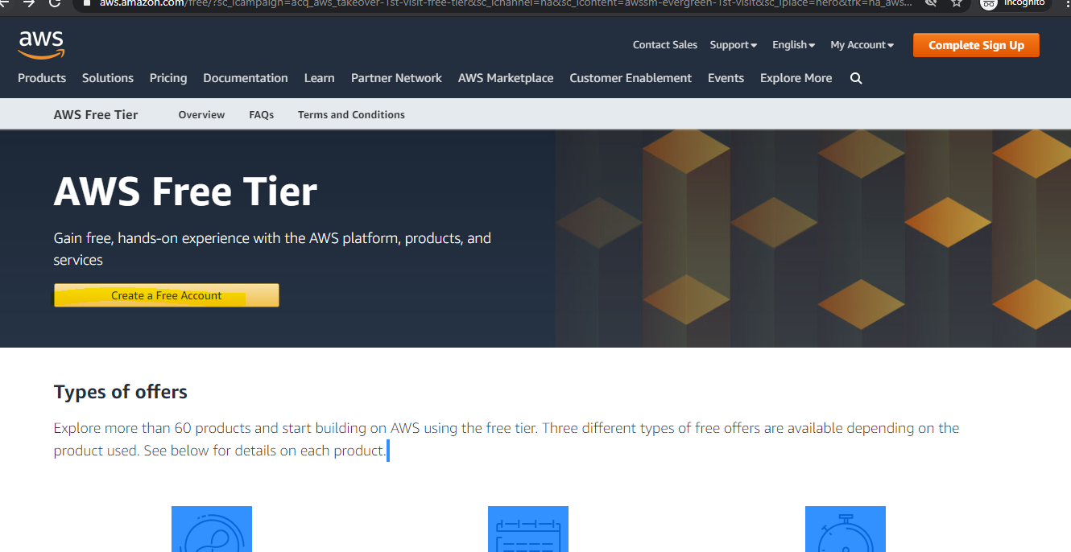

3 . Type personal data

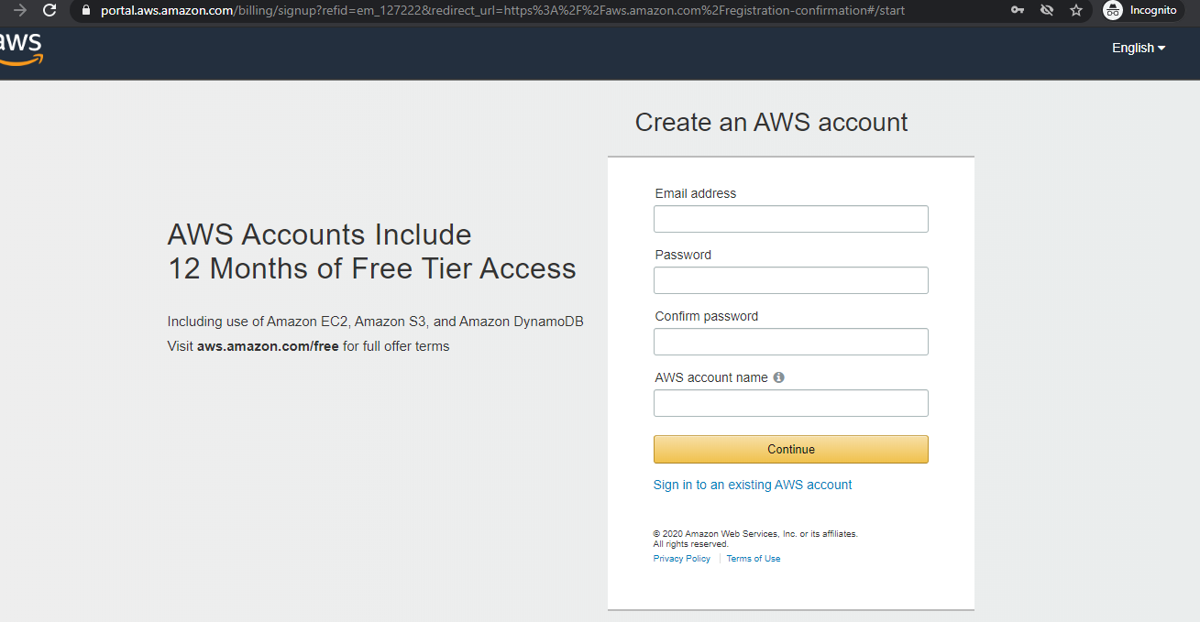

4. Type contact information

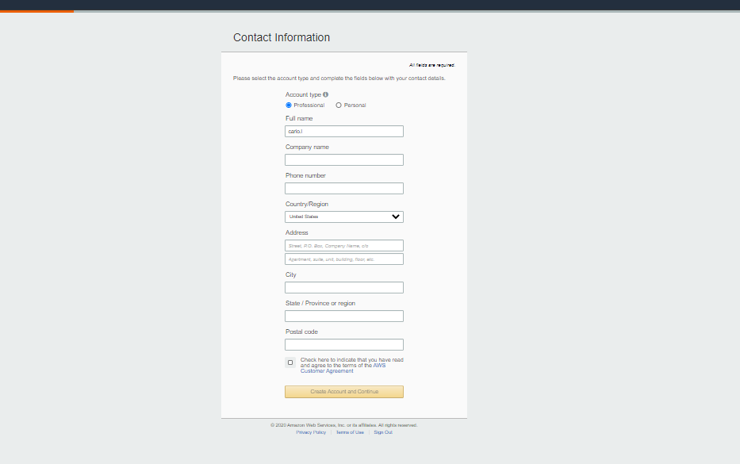

5 type payment data

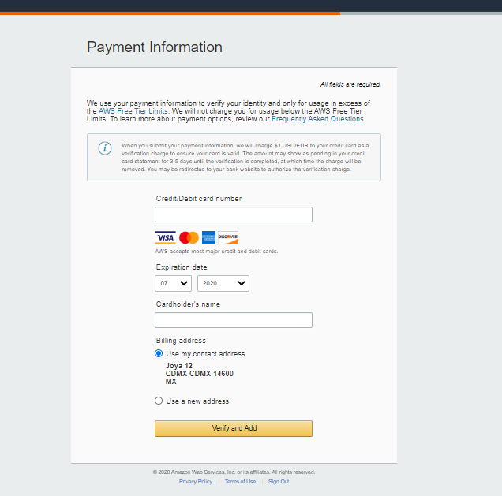

6. Once you verify your account, you need to share the account with us to configure the services.